# Using the templating engine GUI

1. Using chrome, download this browser extension:
   1. <https://chrome.google.com/webstore/detail/modheader/idgpnmonknjnojddfkpgkljpfnnfcklj?hl=en>
   2. We will use this to add the API key for authentication
   3. Our API key is **4a4b6195-e5b1-44cb-96f2-cd195839f1a6**
   4. Add the header “template-api-key” like below
   5. 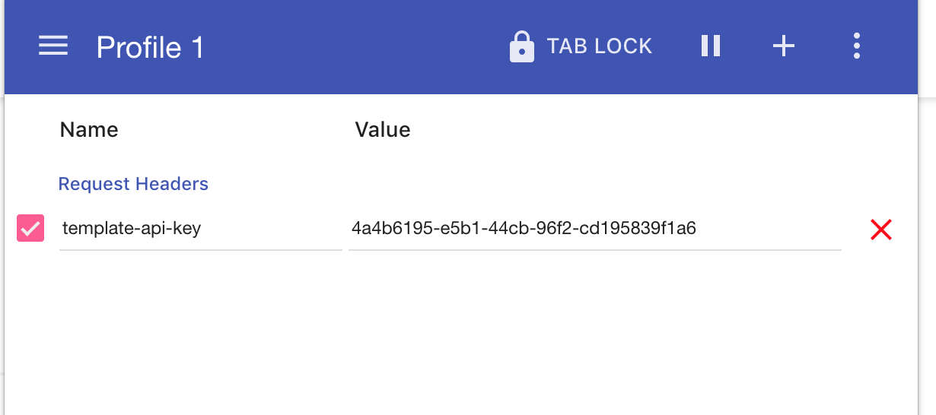
2. With our authentication set now lets navigate to the address below and create a report
   1. Link: <http://13.58.157.47:8081/createReport>
   2. You will see the template we are using is “invoiceTemplate.docx”, take a look at this before generating the template to see what we are replacing
   3. You can see get the template here: <http://13.58.157.47:8081/template/invoiceTemplate.docx>
3. Now we need to change the variables set in the template, go ahead and manipulate the placeholders to a proper company name etc.
   1. You can generate with the following options
   2. 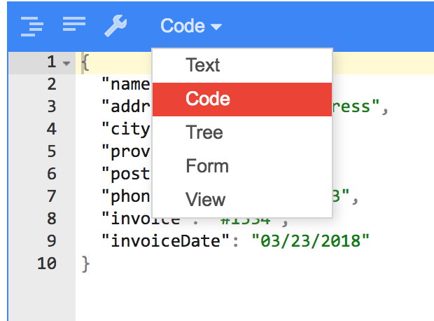
4. Now select a file name if you like and generate the template, a link will be provided after generation, copy and paste this to view the PDF report

# Using the templating engine API

1. Please refer to API documentation for this
2. Doc: <https://app.swaggerhub.com/apis/m2jobe/FrancisTemplatingEngine/docs/1.0.0>